Tom Chrisman – Mount Vernon S.A.R. Dunwoody, Georgia
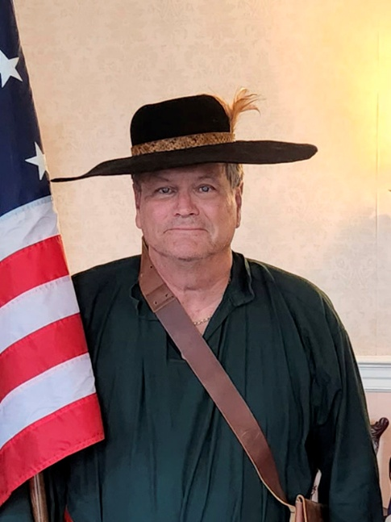
Contact Information:
eMail: registrar_genealogist@aol.com
Cell Phone & Text: (404) 310-3338
Fees: No charge to school, church, veteran, DAR, SAR and CAR groups.
Travel Range: Preference is within 50 miles of metro-Atlanta.
Audio-Visual Equipment: – Will need an LCD/Projector that connects to a laptop for display of PowerPoint slides. Microphone/speaker system should be provided if venue room is large.
Lecturing Credentials:
- Member of Toastmasters International.
- Published author
- Experienced Speaker specializing in Genealogical Research.
Lecture Topics: Can present topic in Colonial Uniform upon request.
- Colonial Migration before the Revolution
- Basics in Genealogy Research
- Traveling Trunk Presentations – A presentation of colonial life to elementary and middle school students. Example items: tools, utensils, clothing, colonial artifacts. Presented in Colonial attire.
- Specialty Lecture Topics: Various Genealogy and Revolutionary War topics. Can build specific presentations upon request.
Biography: Tom has been a resident of the Atlanta area since 1968. He earned his AA and BA degrees from Emory University in Clinical and Experimental Psychology. His career included mental health counseling, and 45 years in sales of eye-related surgical systems. Tom has been a genealogist since 2004, specializing in Colonial and Medieval history. A member in 30 hereditary societies including colonial and medieval societies, and a member of the Georgia Chapter, Association of Professional Genealogists.
Current and Past Offices Held in Societies:
- Registrar General/Genealogist, National Society, Sons & Daughters of the Pilgrims
- State Registrar/Genealogist, GA Society of the War of 1812
- Genealogist, Georgia Society of Colonial Wars
- Genealogist, Georgia Society, Sons of the American the Revolution
- Registrar/Genealogist, Mt. Vernon Chapter, SAR (Dunwoody, GA)
- Past SE District Registrar/Genealogist, Order of the Founders of North America
- Past State Registrar/Genealogist, GA Branch, National Society of Sons & Daughters of Pilgrims
- Past Registrar/Genealogist, Nathaniel Greene Chapter, Georgia Society, Sons of the Revolution
- Past Registrar/Genealogist, Piedmont Chapter, Sons of the American the Revolution
- Registrar/Genealogist for Piedmont Chapter SAR (2009-2014)
- Registrar/Genealogist for SR (2014-2016)
- Registrar/Genealogist for 1812 (2009-present)
- Registrar/Genealogist for Founders of North America (2014)
- Registrar/Genealogist for Colonial Wars (2009-present)
SAR Awards:
- Bronze Good Citizenship Medal (2011)
- Distinguished Service Certificate (2011)
- Liberty Medal (2018)
- Bronze Roger Sherman Medal (2021) / Oak Leaf Cluster (2025)
- Distinguished Service Certificate (2011)
last edit: 9/05/2026

