Shep Hammack – Mount Vernon S.A.R. Dunwoody, Georgia
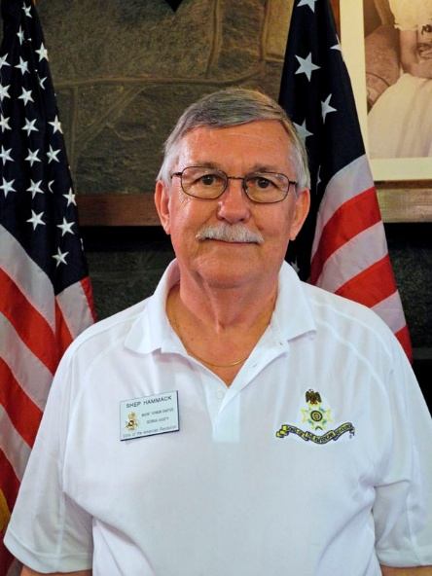
Contact Information:
eMail: shep7h@aol.com
Phone: (678) 592-6463
Fees: No charge to school, church, veteran, DAR, SAR and CAR groups.
Travel Range: Preference is within 50 miles of metro-Atlanta.
Attire: Can present topics in a Revolutionary War Uniform upon request.
Audio-Visual Equipment: Will need an LCD/Projector that connects to a laptop for display of PowerPoint slides. Microphone/speaker system should be provided if venue room is large.
Lecture Topics: Can present topic in Colonial Uniform upon request.
- Flags of the Revolutionary War Era -
- Hyam Salomon - 'Financier of the American Revolution' -
- Traveling Trunk Presentations - A presentation of American colonial lifestyle items to elementary and middle school students, or adult groups. Examples of items are: tools, utensils, clothing, household items and other colonial artifacts. Presented in a Revolutionary War Uniform.
Biography: Retired electrical engineer from Westinghouse Electric. Past officer in the Piedmont Chapter. Founder, President and current officer of the Mount Vernon Chapter. Past Georgia Society SAR officer and currently Metro Regional VP. Recipient of many National, State and Chapter SAR awards.
SAR Officer:
- Founder / 1st President of the Mount Vernon Chapter (2016 - Feb 2018)
- Chapter Historian (2019 - 2025)
- Chapter Treasurer (2025)
- Chapter Genealogist & Registrar (2026)
- GA State SAR C.A.R. & DAR Liaison (2021, 2022)
- GA State SAR Metro Regional VP (2023 - 2025)
- GA State SAR Treasurer (2015, 2019 - 2021)
- State Metro Regional Vice President (2023 to Present)
- National Society SAR/DAR Liaison Committee Chairman (2023)
SAR Awards:
Piedmont Chapter
- 2013 - Jack Martin Membership Trophy
- 2014 - Jack Martin Membership Trophy
- 2014 - Liberty Medal
- 2015 - Bronze Roger Sherman Medal
- 2015 - Bronze Color Guard Medal
- 2015 - Jack Martin Membership Trophy
- 2015 - Silver Color Guard Medal
Mount Vernon Chapter
- 2016 - Jack Martin Membership Trophy
- 2016 - Patriot Grave Marking Medal
- 2020 - Distinguished Service Medal
- 2021 - Certificate of Appreciation (Chapter)
- 2024 - Meritorious Service Medal (Chapter-Bronze)
GASSAR (State Society SAR)
- 2016 - Silver Good Citizenship Medal
- 2016 - Silver Meritorious Service Medal
- 2018 - Silver Roger Sherman Medal
- 2018 - State Honor-Color Guard Status
- 2021 - Silver Roger Sherman Medal - Oak Leaf Cluster
NSSAR (National Society SAR)
- 2016 - Patriot Medal (National Award)
- 2016 - Robert B. Vance Membership Trophy (National Award)
- 2019 - Liberty Medal - Oak Leaf Cluster (National Award)
- 2019 - Certificate of Appreciation (National)
- 2020 - Certificate of Appreciation (National)
- 2021 - Gold Roger Sherman Medal
- 2024 - NSSAR Von Steuben Color Guard Medal
last edit: 09/05/2026

