What is the Mount Vernon S.A.R. Traveling Trunk?
Simply put, it is the SAR's version of a 'Show and Tell of American Revolution History’ and is designed for Grade or Middle School children.

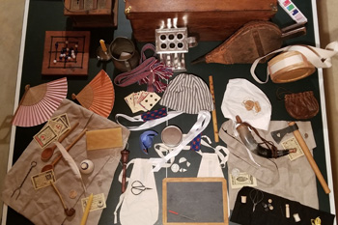
Larger High Rez Image
One of the most enjoyable methods of communicating our American history with school children is via the "Traveling Trunk". This is a program where members of the SAR, dressed in authentic uniforms, present articles from the Revolutionary War & Colonial period to a group of grade school or middle school students engaged in American History curriculum. Presenters explain what the items are, how they were made and used, and why they are different from today's items. This program is one of the Sons of the American Revolution missions - Assisting schools and teachers to sustain and preserve our history.
Letter to Schools
Here is our Chapter introduction letter to schools: Letter to Educators
Educators in the Sandy Springs/Dunwoody school districts can bring Colonial & Revolutionary War History alive with the Traveling Trunk !
Interested? eMail Us
Our Education Chairman will respond as quickly as possible.

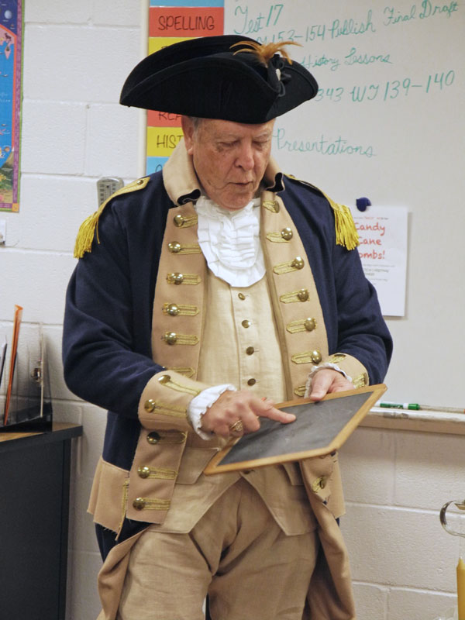
The 1700's iPad/eMail?
A few Schools Visited
Mount Bethel Elementary School
Atlanta Christian Academy
Cary Reynolds Elementary
Lake Forest Elementary
Holy Innocents Episcopal School
Cherokee Christian School
Macedonia Elementary
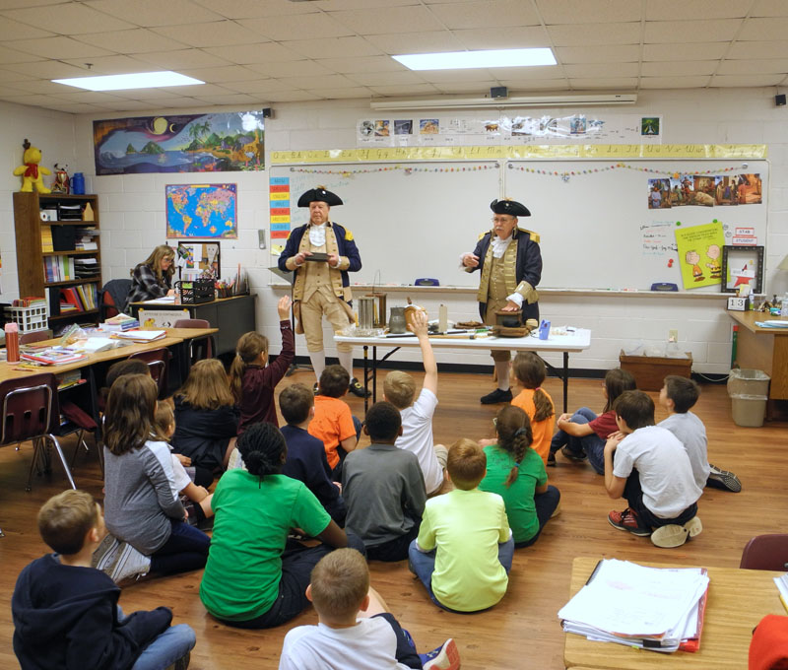
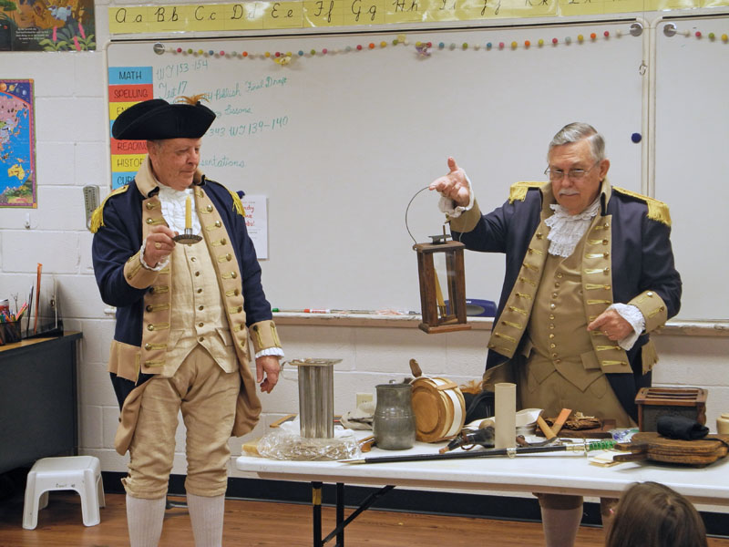
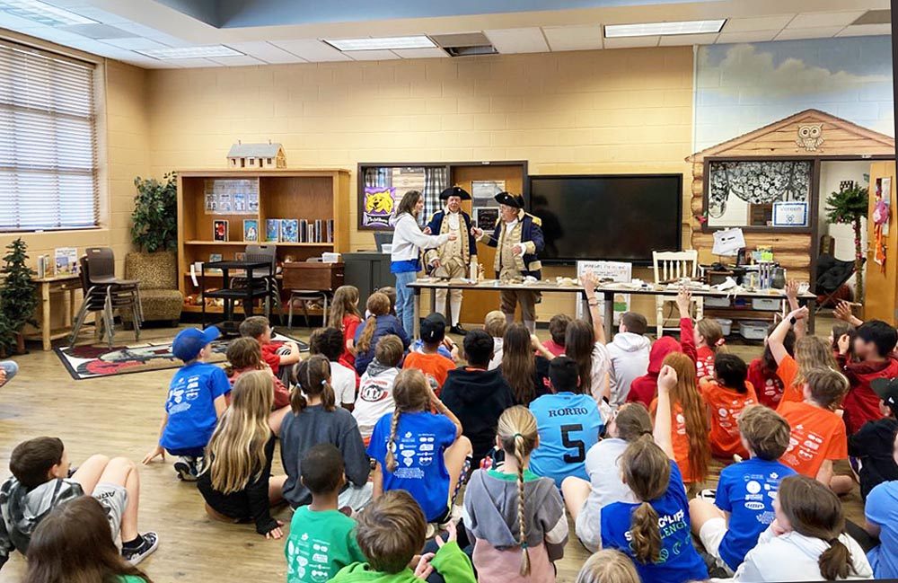
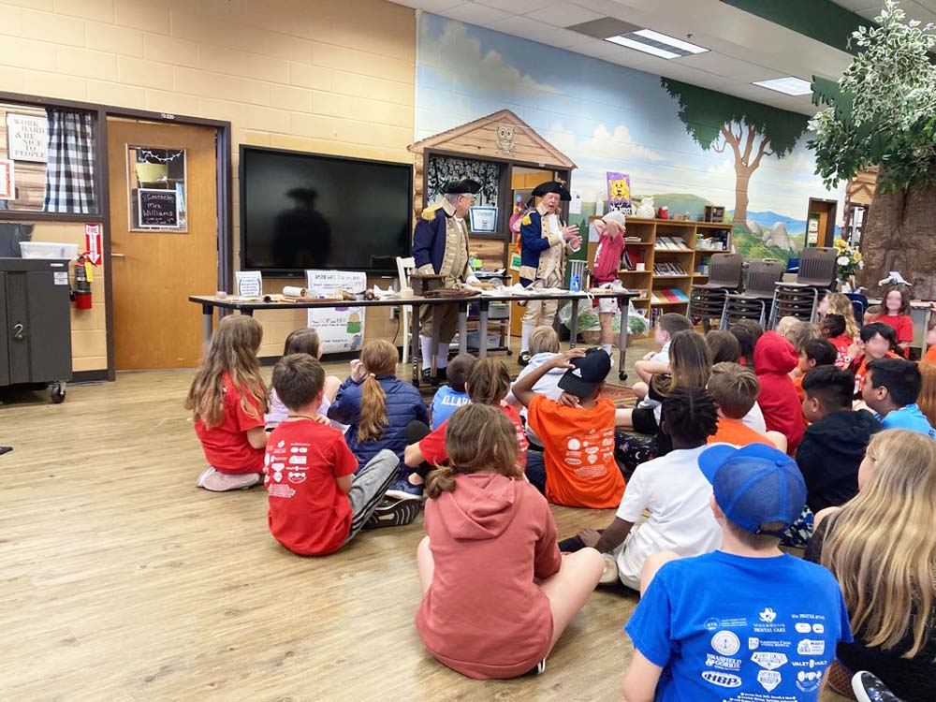
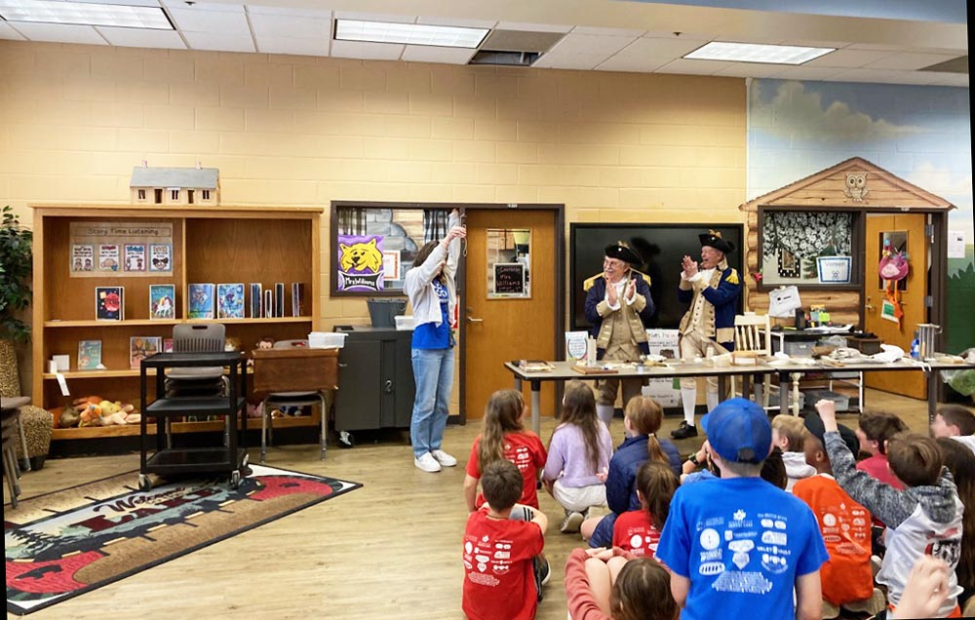
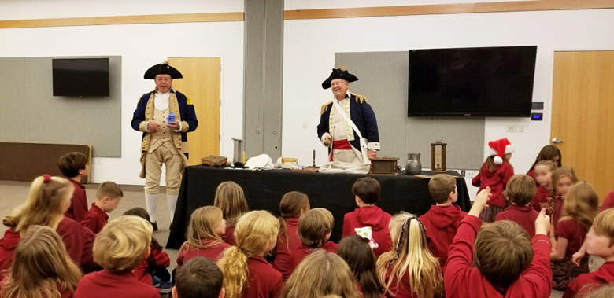

The Traveling Trunk
(For Adult Groups)
Our Speakers Bureau Program is also offered to fellow SAR & DAR Chapters, fellow genealogical or historical societies, Rotary, Kiwanis, or other community service groups that can utilize speakers.
Last Updated 09/05/2026

